Project Management Overview | CIRES

Two Models: People Model + Process Model
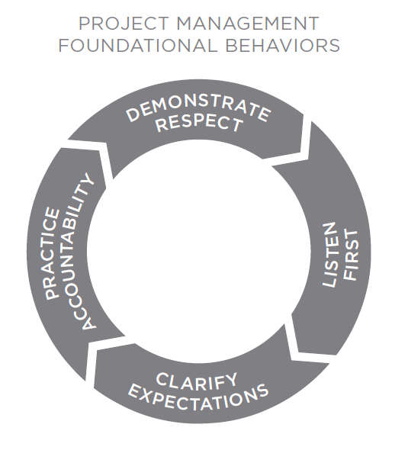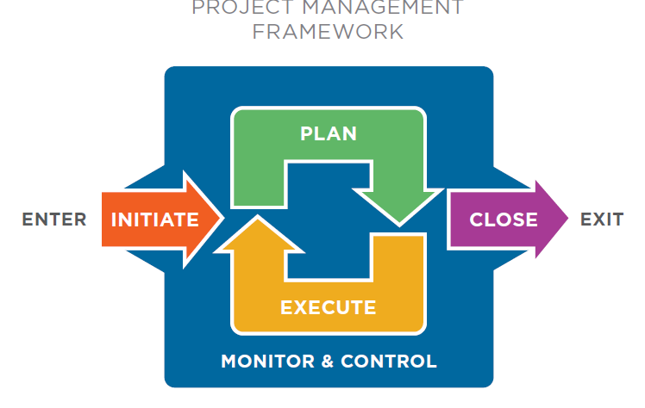
Notes

Initiate
MINDSET: Clarify and shared and measurable set of expectations
QUESTIONS TO ANSWER:
- Who is impacted by the project?
- Who determines success, and what are their expectations?
- What are the project limitations?
- How do you create a shared understanding of the project outcomes?
SKILLS:
- Identify all stakeholders
- Interview key stakeholders
- Document project scope

Notes:

Plan
MINDSET: Create a clear roadmap for smart decision making
QUESTIONS TO ANSWER:
- How do you manage risks?
- How do you break a project down into manageable pieces?
- How do you schedule project deliverables and their associated components?
- How do you identify necessary resources?
- How do you determine communication channels?
SKILLS:
- Plan a risk management strategy
- Create a project schedule
- Develop a communication plan

Notes:

Execute
MINDSET: Engage people through consistent and shared accountability
QUESTIONS TO ANSWER:
- How do you keep people engaged throughout the project?
- How do you create team accountability?
- How do you give effective performance feedback?
SKILLS:
- Create a cadence of accountability
- Hold performance conversations

Notes:

Monitor & Control
MINDSET: Drive progress through transparent communication
QUESTIONS TO ANSWER:
- How do I keep key stakeholders informed about project status?
- How do you effectively manage scope change?
SKILLS:
- Report project status
- Manage scope change

Notes:

Close
MINDSET: Measure success and get better
QUESTIONS TO ANSWER:
- Why close projects?
- How do you carry forward lessons learned from projects?
SKILLS:
- Document lessons learned
- Close the project

Notes:

